**Lesson 10: Storing data with Room**

10.0: SQLite primer

**Contents:**

* [SQL databases](https://google-developer-training.github.io/android-developer-fundamentals-course-concepts-v2/unit-4-saving-user-data/lesson-10-storing-data-with-room/10-0-c-sqlite-primer/10-0-c-sqlite-primer.html#databases)
* [SQLite](https://google-developer-training.github.io/android-developer-fundamentals-course-concepts-v2/unit-4-saving-user-data/lesson-10-storing-data-with-room/10-0-c-sqlite-primer/10-0-c-sqlite-primer.html#sqlite)
* [Example table](https://google-developer-training.github.io/android-developer-fundamentals-course-concepts-v2/unit-4-saving-user-data/lesson-10-storing-data-with-room/10-0-c-sqlite-primer/10-0-c-sqlite-primer.html#table)
* [Transactions](https://google-developer-training.github.io/android-developer-fundamentals-course-concepts-v2/unit-4-saving-user-data/lesson-10-storing-data-with-room/10-0-c-sqlite-primer/10-0-c-sqlite-primer.html#transactions)
* [Query language](https://google-developer-training.github.io/android-developer-fundamentals-course-concepts-v2/unit-4-saving-user-data/lesson-10-storing-data-with-room/10-0-c-sqlite-primer/10-0-c-sqlite-primer.html#language)
* [Queries for Android SQLite](https://google-developer-training.github.io/android-developer-fundamentals-course-concepts-v2/unit-4-saving-user-data/lesson-10-storing-data-with-room/10-0-c-sqlite-primer/10-0-c-sqlite-primer.html#queries)
* [Cursors](https://google-developer-training.github.io/android-developer-fundamentals-course-concepts-v2/unit-4-saving-user-data/lesson-10-storing-data-with-room/10-0-c-sqlite-primer/10-0-c-sqlite-primer.html#cursors)
* [Learn more](https://google-developer-training.github.io/android-developer-fundamentals-course-concepts-v2/unit-4-saving-user-data/lesson-10-storing-data-with-room/10-0-c-sqlite-primer/10-0-c-sqlite-primer.html#learnmore)

This course assumes that you are familiar with databases in general, SQL databases in particular, and the SQL language used to interact with them. This chapter is a refresher and quick reference only.

SQL databases

SQL databases store data in tables of rows and columns:

* The intersection of a row and column is called a *field*.
* Fields contain data, references to other fields, or references to other tables.
* Rows are identified by unique IDs.
* Columns are identified by names that are unique per table.

Think of a database as a spreadsheet with rows, columns, and cells, where cells can contain data, references to other cells, and links to other sheets.

SQLite

SQLite is a software library. SQLite implements an SQL database engine that has the following characteristics:

* Self-contained (requires no other components)
* Serverless (requires no server backend)
* Zero-configuration (does not need to be configured for your app)
* Transactional (changes within a single transaction in SQLite either occur completely or not at all)

SQLite is the most widely deployed database engine in the world. The source code for SQLite is in the public domain.

For details of the SQLite database, see the [SQLite website](https://www.sqlite.org/about.html).

Example table

SQLite stores data in tables.

Assume the following:

* A database named DATABASE_NAME
* A table named WORD_LIST_TABLE
* Columns for _id, word, and definition

After inserting the words alpha and beta, where alpha has two definitions, the DATABASE_NAME database table named WORD_LIST_TABLE might look like this:

|  |
| --- |
| WORD_LIST_TABLE |
| _id | word | definition |
| 1 | "alpha" | "first letter" |
| 2 | "beta" | "second letter" |
| 3 | "alpha" | "particle" |

You can find what's in a specific row using the _id, or you can retrieve rows by formulating queries that select rows from the table by specifying constraints. You use the SQL query language discussed below to create queries.

Transactions

A *transaction* is a sequence of operations performed as a single logical unit of work. A logical unit of work must exhibit four properties, called the atomicity, consistency, isolation, and durability (ACID) properties, to qualify as a transaction:

* **Atomicity.** Either all of a transaction's data modifications are performed, or none of them are performed. This is true even if the act of writing the change to the disk is interrupted by a program crash, operating system crash, or power failure.
* **Consistency.** When completed, a transaction must leave all data in a consistent state.
* **Isolation.** Modifications made by concurrent transactions must be isolated from the modifications made by any other concurrent transactions. A transaction either recognizes data in the state it was in before another concurrent transaction modified it, or it recognizes the data after the second transaction has completed, but it does not recognize an intermediate state.
* **Durability.** After a transaction has completed, its effects are permanently in place in the system. The modifications persist even in the event of a system failure.

Examples of transactions:

* Transferring money from a savings account to a checking account.
* Entering a term and definition into dictionary.
* Committing a changelist to the master branch.

[More on transactions](https://www.sqlite.org/atomiccommit.html).

Query language

You use a special SQL query language to interact with the database. Queries can be very complex, but there are four basic operations:

* Inserting rows
* Deleting rows
* Updating values in rows
* Retrieving rows that meet given criteria

On Android, the database object provides convenient methods for inserting, deleting, and updating the database. You only need to understand SQL for retrieving data.

[Full description of the query language](https://www.sqlite.org/lang.html).

Query structure

An SQL query is highly structured and contains the following basic parts:

* SELECT word,*description*FROM WORD_LIST_TABLE WHERE word="alpha"

Generic version of sample query:

* SELECT *columns*FROM *table*WHERE *column="value"*

Parts:

* SELECT *columns*: Select the columns to return. Use * to return all columns.
* FROM *table*: Specify the table from which to get results.
* WHERE: Keyword that precedes conditions that have to be met, for example *column="value"*. Common operators are =, LIKE, <, and <code> style="box-sizing: border-box; -webkit-tap-highlight-color: transparent; text-size-adjust: none; -webkit-font-smoothing: antialiased; font-size: inherit;">. To connect multiple conditions, use AND or OR.</code>>
* ORDER BY: Specify ASC for ascending, or DESC for descending. For default order, omit ORDER BY.
* LIMIT: Very useful keyword if you want to only get a limited number of results.

Sample queries

|  |  |  |
| --- | --- | --- |
| 1 | SELECT * FROM WORD_LIST_TABLE | Gets the whole table. |
| 2 | SELECT word, definition FROM WORD_LIST_TABLE WHERE _id > 2 | Returns [["alpha", "particle"]] |
| 3 | SELECT _id FROM WORD_LIST_TABLE WHERE word="alpha" AND definition LIKE "%art%" | Returns the id of the word alpha with the substring art in the definition. [["3"]] |
| 4 | SELECT * FROM WORD_LIST_TABLE ORDER BY word DESC LIMIT 1 | Sorts in reverse and gets the first item. This gives you the last item per sort order. Sorting is by the first column, in this case, the _id. [["3", "alpha", "particle"]] |
| 5 | SELECT * FROM WORD_LIST_TABLE LIMIT 2,1 | Returns 1 item starting at position 2. Position counting starts at 1 (not zero!). Returns [["2", "beta", "second letter"]] |

You can practice creating and querying databases at this [Fiddle website](http://sqlfiddle.com/).

Queries for Android SQLite

You can send queries to the SQLite database of the Android system as raw queries or as parameters.

The [rawQuery(String sql, String[] selectionArgs)](https://developer.android.com/reference/android/database/sqlite/SQLiteDatabase.html#rawQuery(java.lang.String,%20java.lang.String[])) method runs the provided SQL and returns a [Cursor](https://developer.android.com/reference/android/database/Cursor.html) of the result set. The following table shows how the first two sample queries from above would look as raw queries:

|  |  |
| --- | --- |
| 1 | String query = "SELECT * FROM WORD_LIST_TABLE"; rawQuery(query, null); |
| 2 | query = "SELECT word, definition FROM WORD_LIST_TABLE WHERE _id> ? "; String[] selectionArgs = new String[]{"2"} rawQuery(query, selectionArgs) ; |

The [query(String table, String[] columns, String selection, String[] selectionArgs, String groupBy, String having, String orderBy, String limit)](https://developer.android.com/reference/android/database/sqlite/SQLiteDatabase.html#query(java.lang.String,%20java.lang.String[],%20java.lang.String,%20java.lang.String[],%20java.lang.String,%20java.lang.String,%20java.lang.String,%20java.lang.String)) method queries the given table, returning a Cursor over the result set. Here's a query showing how to fill in the arguments:

SELECT * FROM WORD_LIST_TABLE

WHERE word="alpha"

ORDER BY word ASC

LIMIT 2,1;

This query returns:

[["alpha", "particle"]]

Argument examples:

String table = "WORD_LIST_TABLE"

String[] columns = new String[]{"*"};

String selection = "word = ?"

String[] selectionArgs = new String[]{"alpha"};

String groupBy = null;

String having = null;

String orderBy = "word ASC"

String limit = "2,1"

query(table, columns, selection, selectionArgs, groupBy, having, orderBy, limit);

Note that in real code, you wouldn't create variables for null values. See the [SQLiteDatabase documentation](https://developer.android.com/reference/android/database/sqlite/SQLiteDatabase.html) for versions of this method with different parameters.

Cursors

A *cursor* is a pointer into a row of structured data. You can think of a cursor as a pointer to a table row.

A query returns a [Cursor](http://developer.android.com/reference/android/database/Cursor.html) object that points to the first element in the query result. The Cursor class provides methods for moving the cursor through the query result, and methods to get the data from the columns of each row in the result.

When a method returns a Cursor object, you iterate over the result, extract the data, do something with the data, and close the cursor to release the memory.

Learn more

* [SQLite website](https://www.sqlite.org/about.html)
* [Full description of SQL as understood by SQLite](https://www.sqlite.org/lang.html)
* [SQLiteDatabase](https://developer.android.com/reference/android/database/sqlite/SQLiteDatabase.html) class
* [Cursor](http://developer.android.com/reference/android/database/Cursor.html) class

10.1: Room, LiveData, and ViewModel

**Contents:**

* [What are Android Architecture Components?](https://google-developer-training.github.io/android-developer-fundamentals-course-concepts-v2/unit-4-saving-user-data/lesson-10-storing-data-with-room/10-1-c-room-livedata-viewmodel/10-1-c-room-livedata-viewmodel.html#chapterstart)
* [Recommended Architecture Components](https://google-developer-training.github.io/android-developer-fundamentals-course-concepts-v2/unit-4-saving-user-data/lesson-10-storing-data-with-room/10-1-c-room-livedata-viewmodel/10-1-c-room-livedata-viewmodel.html#recommended)
* [Example app architecture](https://google-developer-training.github.io/android-developer-fundamentals-course-concepts-v2/unit-4-saving-user-data/lesson-10-storing-data-with-room/10-1-c-room-livedata-viewmodel/10-1-c-room-livedata-viewmodel.html#example)
* [Gradle files](https://google-developer-training.github.io/android-developer-fundamentals-course-concepts-v2/unit-4-saving-user-data/lesson-10-storing-data-with-room/10-1-c-room-livedata-viewmodel/10-1-c-room-livedata-viewmodel.html#gradle)
* [Entity](https://google-developer-training.github.io/android-developer-fundamentals-course-concepts-v2/unit-4-saving-user-data/lesson-10-storing-data-with-room/10-1-c-room-livedata-viewmodel/10-1-c-room-livedata-viewmodel.html#entity)
* [The DAO (data access object)](https://google-developer-training.github.io/android-developer-fundamentals-course-concepts-v2/unit-4-saving-user-data/lesson-10-storing-data-with-room/10-1-c-room-livedata-viewmodel/10-1-c-room-livedata-viewmodel.html#dao)
* [LiveData](https://google-developer-training.github.io/android-developer-fundamentals-course-concepts-v2/unit-4-saving-user-data/lesson-10-storing-data-with-room/10-1-c-room-livedata-viewmodel/10-1-c-room-livedata-viewmodel.html#livedata)
* [Room database](https://google-developer-training.github.io/android-developer-fundamentals-course-concepts-v2/unit-4-saving-user-data/lesson-10-storing-data-with-room/10-1-c-room-livedata-viewmodel/10-1-c-room-livedata-viewmodel.html#room)
* [Repository](https://google-developer-training.github.io/android-developer-fundamentals-course-concepts-v2/unit-4-saving-user-data/lesson-10-storing-data-with-room/10-1-c-room-livedata-viewmodel/10-1-c-room-livedata-viewmodel.html#repository)
* [ViewModel](https://google-developer-training.github.io/android-developer-fundamentals-course-concepts-v2/unit-4-saving-user-data/lesson-10-storing-data-with-room/10-1-c-room-livedata-viewmodel/10-1-c-room-livedata-viewmodel.html#viewmodel)
* [Displaying LiveData](https://google-developer-training.github.io/android-developer-fundamentals-course-concepts-v2/unit-4-saving-user-data/lesson-10-storing-data-with-room/10-1-c-room-livedata-viewmodel/10-1-c-room-livedata-viewmodel.html#displaying)
* [Lifecycle-aware components](https://google-developer-training.github.io/android-developer-fundamentals-course-concepts-v2/unit-4-saving-user-data/lesson-10-storing-data-with-room/10-1-c-room-livedata-viewmodel/10-1-c-room-livedata-viewmodel.html#lifecycle)
* [Paging library](https://google-developer-training.github.io/android-developer-fundamentals-course-concepts-v2/unit-4-saving-user-data/lesson-10-storing-data-with-room/10-1-c-room-livedata-viewmodel/10-1-c-room-livedata-viewmodel.html#paginglibrary)
* [Summary](https://google-developer-training.github.io/android-developer-fundamentals-course-concepts-v2/unit-4-saving-user-data/lesson-10-storing-data-with-room/10-1-c-room-livedata-viewmodel/10-1-c-room-livedata-viewmodel.html#summary)
* [Related practicals](https://google-developer-training.github.io/android-developer-fundamentals-course-concepts-v2/unit-4-saving-user-data/lesson-10-storing-data-with-room/10-1-c-room-livedata-viewmodel/10-1-c-room-livedata-viewmodel.html#relatedpractical)
* [Learn more](https://google-developer-training.github.io/android-developer-fundamentals-course-concepts-v2/unit-4-saving-user-data/lesson-10-storing-data-with-room/10-1-c-room-livedata-viewmodel/10-1-c-room-livedata-viewmodel.html#learnmore)

What are Android Architecture Components?



The Android OS manages resources aggressively to perform well on a huge range of devices, and sometimes that makes it challenging to build robust apps. [Android Architecture Components](https://developer.android.com/topic/libraries/architecture/index.html) provide guidance on app architecture, with libraries for common tasks like lifecycle management and data persistence.

Architecture Components help you structure your app in a way that is robust, testable, and maintainable with less boilerplate code. Architecture Components provide a simple, flexible, and practical approach that frees you from some common problems so you can focus on building great experiences.

Recommended Architecture Components

To introduce the terminology, here is a short introduction to the Architecture Components and how they work together. Each component is explained more in the following sections. This diagram shows a basic form of this architecture.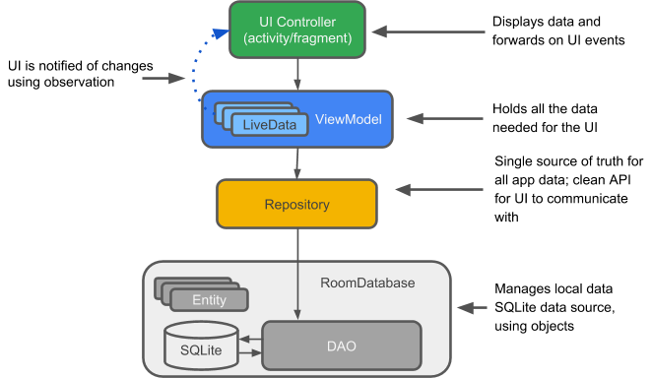

*Entity:* When working with Architecture Components, the entity is an annotated class that describes a database table.

*SQLite database:* On the device, data is stored in an SQLite database. For simplicity, additional storage options, such as a web server, are omitted from this chapter. The [Room persistence library](https://developer.android.com/training/data-storage/room/index.html) creates and maintains this database for you.

*DAO:* Data access object. A mapping of SQL queries to functions. You used to have to define these queries in a helper class, such as [SQLiteOpenHelper](https://developer.android.com/reference/android/database/sqlite/SQLiteOpenHelper.html). When you use a DAO, you call the methods, and the components take care of the rest.

*Room database:* Database layer on top of SQLite database that takes care of mundane tasks that you used to handle with a helper class, such as SQLiteOpenHelper. Provides easier local data storage. The Room database uses the DAO to issue queries to the SQLite database.

*Repository:* A class that you create for managing multiple data sources, for example using the WordRepository class.

*ViewModel:* Provides data to the UI and acts as a communication center between the Repository and the UI. Hides the backend from the UI. ViewModel instances survive device configuration changes.

*LiveData:* A data holder class that follows the [observer pattern](https://en.wikipedia.org/wiki/Observer_pattern), which means that it can be observed. Always holds/caches latest version of data. Notifies its observers when the data has changed. LiveData is lifecycle aware. UI components observe relevant data. LiveData automatically manages stopping and resuming observation, because it's aware of the relevant lifecycle status changes.

Example app architecture

The following diagram shows the same basic architecture form as the diagram above, but in the context of an app. The following sections delve deeper into each component.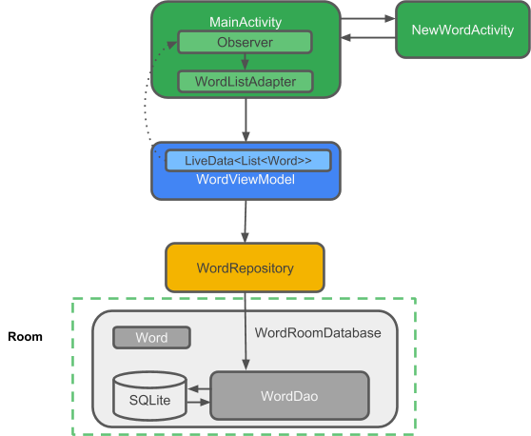

Gradle files

To use the Architecture Components libraries, you must manually add the latest version of the libraries to your Gradle files.

Add the following code to your build.gradle (Module: app) file, at the end of the dependencies block:

// Room components

implementation "android.arch.persistence.room:runtime:$rootProject.roomVersion"

annotationProcessor "android.arch.persistence.room:compiler:$rootProject.roomVersion"

androidTestImplementation "android.arch.persistence.room:testing:$rootProject.roomVersion"

// Lifecycle components

implementation "android.arch.lifecycle:extensions:$rootProject.archLifecycleVersion"

annotationProcessor "android.arch.lifecycle:compiler:$rootProject.archLifecycleVersion"

Get the current version numbers from the [Adding Components to your Project](https://developer.android.com/topic/libraries/architecture/adding-components.html) page. In your build.gradle (Project: RoomWordsSample) file, add the version numbers to the end of the file, as shown in the code below:

ext {

roomVersion = '1.0.0'

archLifecycleVersion = '1.0.0'

}

Entity

The data for an app with a database centers around the data stored in the database. Of course, there can be other data from different sources, but for simplicity, this discussion ignores other data.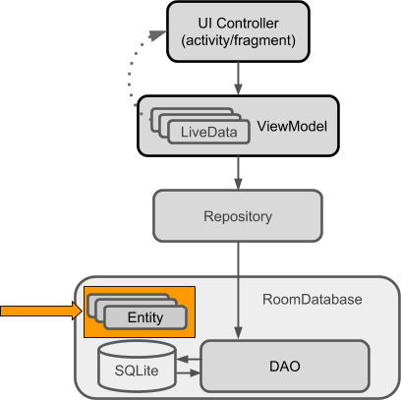

Room models an SQLite database, and is implemented with an SQLite database as its backend. SQLite databases store their data in tables of rows and columns. Each row represents one entity (or record), and each column represents a value in that entity. For example, an entity for a dictionary entry might include a unique ID, the word, a definition, grammatical information, and links to more info.

|  |  |  |  |
| --- | --- | --- | --- |
| **ID** | **First name** | **Last name** | **...** |
| 12345 | Aleks | Becker | ... |
| 12346 | Jhansi | Kumar | ... |

Another common entity is for a person, with a unique ID, first name, last name, email address, and demographic information. The entities in such a database might look like this:

When you write an app using Architecture Components (or an SQLite database), you define your entity or entities in classes. Each instance of the class represents a row, and each column is represented by a member variable.

Here is code representing a Person entity:

public class Person {

private int uid;

private String firstName;

private String lastName;

}

Entity annotations

For Room to work with an entity, you need to give Room information that relates the contents of the entity's Java class (for example Person) to what you want to represent in the database table. You do this using annotations.

Here are some commonly used annotations:

* @Entity(tableName =**"word_table"**) Each @Entity instance represents an entity in a table. Specify the name of the table if you want it to be different from the name of the class.
* @PrimaryKey Every entity needs a primary key. To [auto-generate](https://developer.android.com/reference/android/arch/persistence/room/PrimaryKey.html) a unique key for each entity, add and annotate a primary integer key with autoGenerate=true, as shown in the code below. See [Defining data using Room entities](https://developer.android.com/training/data-storage/room/defining-data.html).
* @NonNull Denotes that a parameter, field, or method return value can never be null. The primary key should always use the @NonNull annotation. Use this annotation for mandatory fields in your rows.
* @ColumnInfo(name =**"word"**) Specify the name of the column in the table, if you want the column name to be different from the name of the member variable.

Every field that's stored in the database must either be public or have a "getter" method so that Room can access it. The code below provides a getWord() "getter" method rather than exposing member variables directly.

Here is annotated code representing a Person entity:

@Entity

public class Person {

@PrimaryKey (autoGenerate=true)

private int uid;

@ColumnInfo(name = "first_name")

private String firstName;

@ColumnInfo(name = "last_name")

private String lastName;

// Getters and setters are not shown for brevity,

// but they're required for Room to work if variables are private.

}

You can also use annotations to define relationships between entities. For details and a complete list of annotations, see the [Room package summary reference](https://developer.android.com/reference/android/arch/persistence/room/package-summary.html).

The DAO (data access object)

To access your app's data using the [Room persistence library](https://developer.android.com/training/data-storage/room/index.html), you work with *data access objects*, or *DAO*s. A set of [Dao](https://developer.android.com/reference/android/arch/persistence/room/Dao.html) objects (DAOs) forms the main component of a Room database. Each DAO includes methods that offer abstract access to your app's database.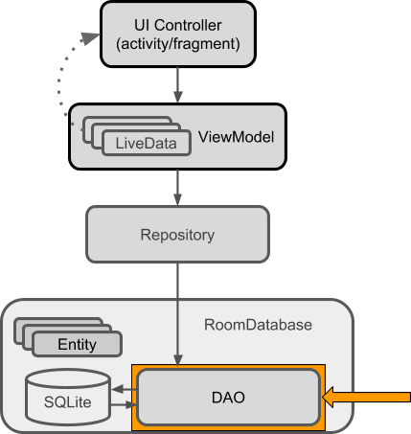

You annotate the DAO to specify SQL queries and associate them with method calls. The compiler checks the SQL for errors, then generates queries from the annotations. For common queries, the libraries provide convenience annotations, such as @Insert, @Delete, and @Update.

Note that:

* The DAO must be an interface or abstract class.
* Room uses the DAO to create a clean API for your code.
* By default, queries (@Query) must be executed on a thread other than the main thread. For operations such as inserting or deleting, Room takes care of thread management for you if you use the appropriate annotations.
* The default action when you ask Room to insert an entity that is already in the database is to ABORT. You can specify a different conflict strategy, such as REPLACE.

Here is code that demonstrates these annotations along with different types of queries:

@Dao

public interface WordDao {

// The conflict strategy defines what happens,

// if there is an existing entry.

// The default action is ABORT.

@Insert(onConflict = OnConflictStrategy.REPLACE)

void insert(Word word);

// Update multiple entries with one call.

@Update

public void updateWords(Word... words);

// Simple query that does not take parameters and returns nothing.

@Query("DELETE FROM word_table")

void deleteAll();

// Simple query without parameters that returns values.

@Query("SELECT * from word_table ORDER BY word ASC")

List<Word> getAllWords();

// Query with parameter that returns a specific word or words.

@Query("SELECT * FROM word_table WHERE word LIKE :word ")

public List<Word> findWord(String word);

}

Learn more about [Room DAOs](https://developer.android.com/training/data-storage/room/accessing-data.html).

LiveData

When your app displays data or uses data in other ways, you usually want to take action when the data changes. This means your app has to observe the data so that when it changes, the app can react. Depending on how the data is stored, this can be tricky. Observing changes to data across multiple components of your app can create explicit, rigid dependency paths between the components. This makes testing and debugging, among other things, difficult.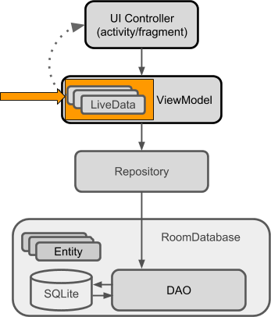

To avoid these problems, use LiveData, which is a [lifecycle library](https://developer.android.com/topic/libraries/architecture/lifecycle.html)class for data observation. If you use a return value of type [LiveData](https://developer.android.com/reference/android/arch/lifecycle/LiveData.html) in your method description, Room generates all necessary code to update the LiveData when the database is updated.

Benefits of using LiveData

*Ensures that your UI matches your data state*

LiveData follows the [observer pattern](https://en.wikipedia.org/wiki/Observer_pattern), so it notifies [Observer](https://developer.android.com/reference/android/arch/lifecycle/Observer.html) objects when the lifecycle state changes. You can consolidate your code to update the UI within these observer objects. Instead of updating the UI every time the app data changes, your observer can update the UI every time there's a state change.

*No memory leaks*

Observers are bound to [Lifecycle](https://developer.android.com/reference/android/arch/lifecycle/Lifecycle.html) objects, and the observers clean up after themselves when their associated lifecycle is destroyed.

*No crashes due to stopped activities*

If the observer's lifecycle is inactive, as in the case of an activity in the back stack, then it doesn't receive any LiveData events.

*No more manual lifecycle handling*

UI components just observe relevant data and don't stop or resume observation. LiveData is aware of relevant lifecycle status changes while observing, so LiveData automatically manages stopping and resuming observation.

*Data is always up-to-date*

If a lifecycle becomes inactive, it receives the latest data upon becoming active again. For example, an activity that was in the background receives the latest data right after it returns to the foreground.

*Configuration changes handled properly*

If an activity or fragment is re-created due to a configuration change, like device rotation, the activity or fragment immediately receives the latest available data.

*Resources can be shared*

You can extend a LiveData object using the [singleton](https://en.wikipedia.org/wiki/Singleton_pattern) pattern. Do this, for example, for services or a database. The LiveData object connects to the system service once, and then any observer that needs the resource can just watch the LiveData object. For more information, see [Extend LiveData](https://developer.android.com/topic/libraries/architecture/livedata.html#extend_livedata).

Using LiveData

Follow these general steps to work with [LiveData](https://developer.android.com/reference/android/arch/lifecycle/LiveData.html) objects:

1. Create an instance of LiveData to hold a certain type of data. This is usually done within your [ViewModel](https://developer.android.com/reference/android/arch/lifecycle/ViewModel.html) class.
2. Create an [Observer](https://developer.android.com/reference/android/arch/lifecycle/Observer.html) object that defines the [onChanged()](https://developer.android.com/reference/android/arch/lifecycle/Observer.html#onChanged(T)) method, which controls what happens when the LiveData object's held data changes. You usually create an Observer object in a UI controller, such as an activity or fragment.
3. Attach the Observer object to the LiveData object using the [observe()](https://developer.android.com/reference/android/arch/lifecycle/LiveData.html#observe(android.arch.lifecycle.LifecycleOwner,%20%20%20android.arch.lifecycle.Observer%3CT%3E)) method. The observe() method takes a [LifecycleOwner](https://developer.android.com/reference/android/arch/lifecycle/LifecycleOwner.html) object. This subscribes the Observer object to the LiveData object so that the observer is notified of changes. You usually attach the Observer object in a UI controller, such as an activity or fragment.

**Note:** You can register an observer without an associated [LifecycleOwner](https://developer.android.com/reference/android/arch/lifecycle/LifecycleOwner.html) object using the [observeForever(Observer)](https://developer.android.com/reference/android/arch/lifecycle/LiveData.html#observeForever(android.arch.lifecycle.Observer%3CT%3E)) method. In this case, the observer is considered to be always active and is therefore always notified about modifications. To remove these observers, call the [removeObserver(Observer)](https://developer.android.com/reference/android/arch/lifecycle/LiveData.html#removeObserver(android.arch.lifecycle.Observer%3CT%3E)) method.

When you update the value stored in the LiveData object, all registered observers are notified and will take specified actions, such as updating the UI, as long as the attached LifecycleOwner is in the active state.

LiveData allows UI-controller observers to subscribe to updates. When the data held by the LiveData object changes, the UI automatically updates in response.

These steps are explained in more detail in the rest of this chapter.

Making data observable with LiveData

To make data observable, wrap it with LiveData. That's it.

For the Person example, in the DAO you would wrap the returned data into LiveData, as shown in this code:

@Query("SELECT * from word_table ORDER BY word ASC")

LiveData<List<Word>> getAllWords();

**Important:** When you pass data through the layers of your app architecture from a Room database to your UI, that data has to be LiveData in all layers: All the data that Room returns to the Repository, and the Repository then passes to the ViewModel, must be LiveData. You can then create an observer in the activity that observes the data in the ViewModel.

MutableLiveData

You can use LiveData independently from Room, but to do so you must manage data updates. However, LiveData has no publicly available methods to update the stored data.

Therefore, if you want to update the stored data, you must use [MutableLiveData](https://developer.android.com/reference/android/arch/lifecycle/MutableLiveData.html) instead of LiveData. The MutableLiveData class adds two public methods that allow you to set the value of a LiveData object: [setValue(T)](https://developer.android.com/reference/android/arch/lifecycle/MutableLiveData.html#setValue(T)) and [postValue(T)](https://developer.android.com/reference/android/arch/lifecycle/MutableLiveData.html#postValue(T)).

MutableLiveData is usually used in the [ViewModel](https://developer.android.com/reference/android/arch/lifecycle/ViewModel.html), and then the ViewModel only exposes immutable LiveData objects to the observers.

See the Architecture Components' [BasicSample](https://github.com/googlesamples/android-architecture-components/tree/master/BasicSample) code for examples of using MutableLiveData. The example in [Guide to App Architecture](https://developer.android.com/topic/libraries/architecture/guide.html) also shows a use MutableLiveData.

Observing LiveData

To update the data that is shown to the user, create an observer of the data in the onCreate() method of MainActivity and override the observer's onChanged() method. When the LiveData changes, the observer is notified and onChanged() is executed. You then update the cached data, for example in the adapter, and the adapter updates what the user sees.

Usually you observe data in a ViewModel, not directly in the Repository or in Room. [ViewModel is described in a later section](https://google-developer-training.github.io/android-developer-fundamentals-course-concepts-v2/unit-4-saving-user-data/lesson-10-storing-data-with-room/10-1-c-room-livedata-viewmodel/10-1-c-room-livedata-viewmodel.html#viewmodel).

The following code shows how to attach an observer to LiveData:

// Create the observer which updates the UI.

final Observer<String> nameObserver = new Observer<String>() {

@Override

public void onChanged(@Nullable final String newName) {

// Update the UI, in this case, a TextView.

mNameTextView.setText(newName);

}

};

mModel.getCurrentName().observe(this, nameObserver);

See the [LiveData](https://developer.android.com/topic/libraries/architecture/livedata.html) documentation to learn other ways to use LiveData, or watch this [Architecture Components: LiveData and Lifecycle](https://www.youtube.com/watch?v=jCw5ib0r9wg) video.

Room database

Room is a database layer on top of an SQLite database. Room takes care of mundane tasks that you used to handle with an [SQLiteOpenHelper](https://developer.android.com/reference/android/database/sqlite/SQLiteOpenHelper.html).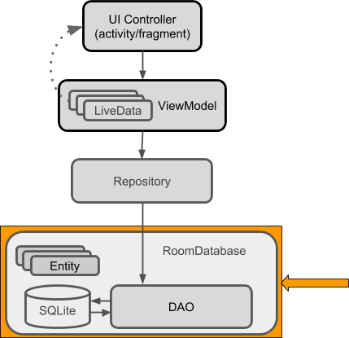

To use Room:

1. Create a public abstract class that extends RoomDatabase.
2. Use annotations to declare the entities for the database and set the version number.
3. Use Room's database builder to create the database if it doesn't exist.
4. Add a migration strategy for the database. When you modify the database schema, you'll need to update the version number and define how to handle migrations. For a sample, destroying and re-creating the database is a fine migration strategy. For a real app, you must implement a migration strategy. See [Understanding migrations with Room](https://medium.com/google-developers/understanding-migrations-with-room-f01e04b07929).

Note that:

* Room provides compile-time checks of SQLite statements.
* By default, to avoid poor UI performance, Room doesn't allow you to issue database queries on the main thread. [LiveData](https://developer.android.com/reference/android/arch/lifecycle/LiveData.html) applies this rule by automatically running the query asynchronously on a background thread, when needed.
* Usually, you only need one instance of the Room database for the whole app. Make your RoomDatabase a [singleton](https://en.wikipedia.org/wiki/Singleton_pattern) to prevent having multiple instances of the database opened at the same time, which would be a bad thing.

Here is a sample of a complete Room class:

@Database(entities = {Word.class}, version = 1)

public abstract class WordRoomDatabase extends RoomDatabase {

public abstract WordDao wordDao();

private static WordRoomDatabase INSTANCE;

static WordRoomDatabase getDatabase(final Context context) {

if (INSTANCE == null) {

synchronized (WordRoomDatabase.class) {

if (INSTANCE == null) {

INSTANCE = Room.databaseBuilder(context.getApplicationContext(),

WordRoomDatabase.class, "word_database")

// Wipes and rebuilds instead of migrating

// if no Migration object.

.fallbackToDestructiveMigration()

.build();

}

}

}

return INSTANCE;

}

}

Repository

A *Repository* is a class that abstracts access to multiple data sources. The Repository is not part of the Architecture Components libraries, but is a suggested best practice for code separation and architecture. A Repository class handles data operations. It provides a clean API to the rest of the app for app data.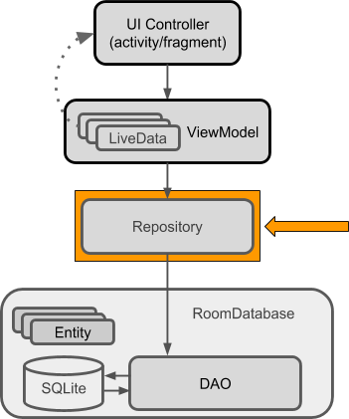

A Repository is where you would put the code to manage query threads and use multiple backends, if appropriate. Once common use for a Repository is to implement the logic for deciding whether to fetch data from a network or use results cached in the database.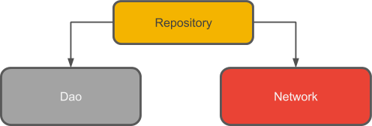

Here is the complete code for a basic Repository:

public class WordRepository {

private WordDao mWordDao;

private LiveData<List<Word>> mAllWords;

WordRepository(Application application) {

WordRoomDatabase db = WordRoomDatabase.getDatabase(application);

mWordDao = db.wordDao();

mAllWords = mWordDao.getAllWords();

}

LiveData<List<Word>> getAllWords() {

return mAllWords;

}

public void insert (Word word) {

new insertAsyncTask(mWordDao).execute(word);

}

private static class insertAsyncTask extends AsyncTask<Word, Void, Void> {

private WordDao mAsyncTaskDao;

insertAsyncTask(WordDao dao) {

mAsyncTaskDao = dao;

}

@Override

protected Void doInBackground(final Word... params) {

mAsyncTaskDao.insert(params[0]);

return null;

}

}

}

**Note:** In this example, the Repository doesn't do much. See the [BasicSample](https://github.com/googlesamples/android-architecture-components/tree/master/BasicSample) for an applied implementation.

The [Guide to App Architecture](https://developer.android.com/topic/libraries/architecture/guide.html) includes a more complex example that uses a web service to fetch data.

ViewModel

The ViewModel is a class whose role is to provide data to the UI and survive configuration changes. A ViewModel acts as a communication center between the Repository and the UI. You can also use a ViewModel to share data between fragments. The ViewModel is part of the [lifecycle library](https://developer.android.com/topic/libraries/architecture/lifecycle.html). For an introductory guide to this topic, see the [ViewModel](https://developer.android.com/topic/libraries/architecture/viewmodel.html) overview.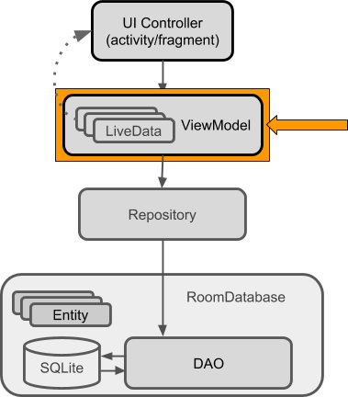

A ViewModel holds your app's UI data in a lifecycle-conscious way that survives configuration changes. Separating your app's UI data from your Activity and Fragment classes lets you better follow the single responsibility principle: Your activities and fragments are responsible for drawing data to the screen, while your ViewModel is responsible for holding and processing all the data needed for the UI.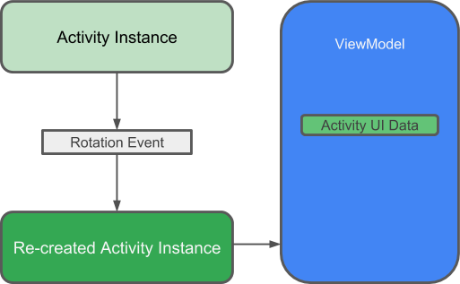

**Warning:**Never pass context into ViewModel instances. Do not store Activity, Fragment, or View instances or their Context in the ViewModel. An Activity can be destroyed and created many times during the lifecycle of a ViewModel, such as when the device is rotated. If you store a reference to the Activity in the ViewModel, you end up with references that point to the destroyed Activity. This is a memory leak. If you need the application context, use AndroidViewModel instead of ViewModel.

In the ViewModel, use LiveData for changeable data that the UI will use or display, so that you can add an observer and respond to changes.

Here is the complete code for a sample ViewModel:

public class WordViewModel extends AndroidViewModel {

private WordRepository mRepository;

private LiveData<List<Word>> mAllWords;

public WordViewModel (Application application) {

super(application);

mRepository = new WordRepository(application);

mAllWords = mRepository.getAllWords();

}

LiveData<List<Word>> getAllWords() { return mAllWords; }

public void insert(Word word) { mRepository.insert(word); }

}

**Important:**ViewModel is not a replacement for onSaveInstanceState(), because the ViewModel does not survive a process shutdown. See [Saving UI States](https://developer.android.com/topic/libraries/architecture/saving-states.html).

To learn more, watch this [Architecture Components: ViewModel](https://www.youtube.com/watch?v=c9-057jC1ZA) video.

Displaying LiveData

Finally, you can display all this interesting data to the user.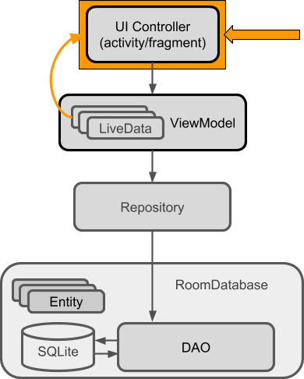

Whenever the data changes, the onChanged() method of your observer is called.

In the most basic case, this can update the contents of a TextView, as shown in this code:

final Observer<String> nameObserver = new Observer<String>() {

@Override

public void onChanged(@Nullable final String newName) {

// Update the UI, in this case, a TextView.

mNameTextView.setText(newName);

}

};

Another common case is to display data in a View that works with an adapter. For example, if you are showing data in a RecyclerView, the onChanged() method updates the data cached in the adapter:

mWordViewModel.getAllWords().observe(this, new Observer<List<Word>>() {

@Override

public void onChanged(@Nullable final List<Word> words) {

// Update the cached copy of the words in the adapter.

adapter.setWords(words);

}

});

**Tip:** One way to get a reference to the application context in a data repository is to extend the Application class and add a member of type Context to that custom subclass.

Lifecycle-aware components

Most of the app components that are defined in the Android framework have lifecycles attached to them. Lifecycles are managed by the operating system or the framework code running in your process. They are core to how Android works and your app must respect them. Not doing so may trigger memory leaks or even app crashes. Activities and fragments are examples of lifecycle-aware components, and LiveData is lifecycle aware.

A common pattern is to implement the actions of the dependent components in the lifecycle methods of activities and fragments. For example, you might have a listener class that connects to a service when the activity starts, and disconnects when the activity is stopped. In the activity, you then override the onStart() and onStop() methods to start and stop the listener.

@Override

public void onStart() {

super.onStart();

myListener.start();

}

This code snippet looks innocent enough. However, once you have multiple components, using this pattern leads to poor code organization and a proliferation of errors, such as possible race conditions.

Lifecycle-aware components perform actions in response to a change in the lifecycle status of another component. For example, a listener could start and stop itself in response to an activity starting and stopping. This results in code that is better-organized, usually shorter, and always easier to maintain.

The [android.arch.lifecycle](https://developer.android.com/reference/android/arch/lifecycle/package-summary.html) package provides classes and interfaces that let you build lifecycle-aware components that automatically adjust their behavior based on the lifecycle state of an activity or fragment. That is, you can make any class lifecycle aware.

* To import [android.arch.lifecycle](https://developer.android.com/reference/android/arch/lifecycle/package-summary.html) into your Android project, see [Adding Components to your Project](https://developer.android.com/topic/libraries/architecture/adding-components.html).
* See [Handling Lifecycles with Lifecycle-Aware Components](https://developer.android.com/topic/libraries/architecture/lifecycle.html) for more details on using these components.

Use cases for lifecycle-aware components

Lifecycle-aware components can make it much easier for you to manage lifecycles in a variety of cases. For example, you can use lifecycle-aware components to:

* *Switch between coarse and fine-grained location updates.*

Use lifecycle-aware components to enable fine-grained location updates while your location app is visible, then switch to coarse-grained updates when the app is in the background. Add [LiveData](https://developer.android.com/reference/android/arch/lifecycle/LiveData.html) to automatically update the UI when your user changes locations.

* *Stop and start video buffering.*

Use lifecycle-aware components to start video buffering as soon as possible, but defer playback until the app is fully started. You can also use lifecycle-aware components to end buffering when your app is destroyed.

* *Start and stop network connectivity.*

Use lifecycle-aware components to enable live updating (streaming) of network data while an app is in the foreground, then automatically pause when the app moves into the background.

* *Pause and resume animated drawables.*

Use lifecycle-aware components to pause animated drawables while the app is in the background, then resume drawables after the app returns to the foreground.

Lifecycle basic example

To use basic lifecycle observation, add an observer to the lifecycle that you want to observe, and specify what you want to happen for the lifecycle events you are interested in.

Below is the code for a very simple LifecycleObserver implementation. In a real project, you would want to do more useful things, such as connecting to a service or polling a sensor.

**Note:** You can display a toast on start and stop, because the method for starting is executed after the activity is started, while the method associated with stopping executes before the activity is stopped or destroyed.

public class MainActivity extends AppCompatActivity {

private Aquarium myAquarium;

protected void onCreate(Bundle savedInstanceState) {

super.onCreate(savedInstanceState);

setContentView(R.layout.activity_main);

// Create an aquarium. Pass in the context and lifecycle you

// want to observe. In this case, the context is the application,

// and the lifecycle of this activity.

myAquarium = new Aquarium(this.getApplication(), getLifecycle());

}

}

// Add lifecycle awareness to this POJO that could be doing much more

// complex things. For example, if you have fish, they could stop moving

// when the app is not in the foreground, to save resources.

public class Aquarium {

// Constructor that receives the Application and a lifecycle.

public Aquarium(final Application app, Lifecycle lifecycle) {

// Create and add a new observer to the lifecycle.

lifecycle.addObserver(new LifecycleObserver() {

// Use annotation to indicate where in the lifecycle the

// following method should run. In the method, do whatever

// you want to happen on start.

@OnLifecycleEvent(Lifecycle.Event.ON_START)

public void start() {

Log.d("LifecycleListener", "LIGHTS ON");

Toast.makeText(app, "LIGHTS ON",

Toast.LENGTH_SHORT).show();

}

@OnLifecycleEvent(Lifecycle.Event.ON_STOP)

public void stop() {

Log.d("LifecycleListener", "LIGHTS OFF");

Toast.makeText(app, "LIGHTS OFF",

Toast.LENGTH_SHORT).show();

}

});

}

}

Paging library

The [paging library](https://developer.android.com/topic/libraries/architecture/paging.html) makes it easier for your app to gradually load information as needed from a data source, without overloading the device or waiting too long for a big database query.

Many apps work with large sets of data, but only need to load and display a small portion of that data at a time. An app might have thousands of items that it can display, but it might only need access to a few dozen of these items at once. If the app isn't designed with care, it can request data that it doesn't need, which places a performance burden on the device, and on the network. If the data is stored or synchronized with a remote database, this can also slow the app and waste the user's data plan.

The paging library addresses issues with existing solutions. This library contains several classes to streamline the process of requesting data as you need it. These classes also work seamlessly with existing Architecture Components like [Room](https://developer.android.com/topic/libraries/architecture/room.html).

Learn more about the [paging library](https://developer.android.com/topic/libraries/architecture/paging.html) in the official documentation.

Summary

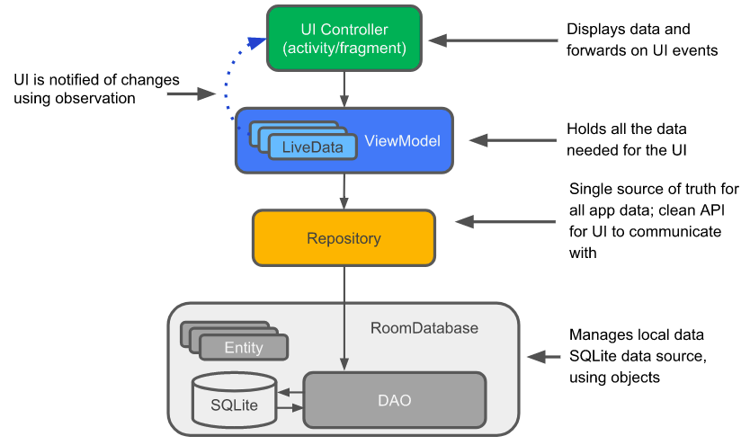

Suppose you have an app that displays data, for example in a list in a RecyclerView, and you can add data to that list, or change data in the list. If the app implements the architecture shown in the diagram above, then the following are true:

* Some of that data is based on an instance of an Entity class, which represents an entity in a repository.
* The Adapter caches the list of data, and the list is automatically updated and redisplayed when the data changes.
* The automatic update happens because in the MainActivity, there is an Observer that observes the data and is notified when it changes. When there is a change, the observer's onChange() method is executed and updates the cached data in the Adapter.
* The data can be observed because it is LiveData. And what is observed is the LiveData<List<Entity>> that is returned by a method in the ViewModel object.
* The ViewModel hides everything about the backend from the user interface. It provides methods for accessing the UI data, and it returns LiveData so that MainActivity can set up the observer relationship. Views, activities, and fragments only interact with the data through the ViewModel. As such, it doesn't matter where the data comes from.
* In this case, the data comes from a Repository. The ViewModel does not need to know what that Repository interacts with. It just needs to know how to interact with the Repository, which is through the methods exposed by the Repository.
* The Repository manages one or more data sources. For this architecture, that backend is a Room database. Room is a wrapper around and implements an SQLite database. Room does a lot of work for you that you used to have to do yourself. For example, Room does everything that you used to use an SQLiteOpenHelper class to do.
* The DAO maps method calls to database queries, so that when the Repository calls a method such as getAllEntities(), Room can execute **SELECT * from table ORDER BY entity ASC.**
* The result returned from the query is observed LiveData. Therefore, every time the data in Room changes, the Observer interface's onChanged() method is executed and the UI is updated.

Related practicals

This concept chapter has two related codelab practicals:

* [10.1 Part A: Room, LiveData, and ViewModel](https://codelabs.developers.google.com/codelabs/android-training-livedata-viewmodel)
* [10.1 Part B: Room, LiveData, and ViewModel](https://codelabs.developers.google.com/codelabs/android-training-room-delete-data)

Learn more

Android developer documentation:

* [Guide to App Architecture](https://developer.android.com/topic/libraries/architecture/guide.html)
* [Adding Components to your Project](https://developer.android.com/topic/libraries/architecture/adding-components.html)
* [DAO](https://developer.android.com/reference/android/arch/persistence/room/Dao.html)
* [Room DAOs](https://developer.android.com/training/data-storage/room/accessing-data.html)
* [Room package summary reference](https://developer.android.com/reference/android/arch/persistence/room/package-summary.html)
* [Handling Lifecycles with Lifecycle-Aware Components](https://developer.android.com/topic/libraries/architecture/lifecycle.html)
* [LiveData](https://developer.android.com/reference/android/arch/lifecycle/LiveData.html)
* [MutableLiveData](https://developer.android.com/reference/android/arch/lifecycle/MutableLiveData.html)
* [ViewModel](https://developer.android.com/reference/android/arch/lifecycle/ViewModel.html)
* [ViewModelProviders](https://developer.android.com/reference/android/arch/lifecycle/ViewModelProviders.html)
* [Defining data using Room entities](https://developer.android.com/training/data-storage/room/defining-data.html)

Blogs and articles:

* [7 Steps To Room](https://medium.com/google-developers/7-steps-to-room-27a5fe5f99b2) (migrating an existing app)
* [Understanding migrations with Room](https://medium.com/google-developers/understanding-migrations-with-room-f01e04b07929)
* [Lifecycle Aware Data Loading with Architecture Components](https://medium.com/google-developers/lifecycle-aware-data-loading-with-android-architecture-components-f95484159de4)

Codelabs:

* [Android Persistence codelab](https://codelabs.developers.google.com/codelabs/android-persistence/#0) (LiveData, Room, DAO)
* [Android lifecycle-aware components codelab](https://codelabs.developers.google.com/codelabs/android-lifecycles/#0) (ViewModel, LiveData, LifecycleOwner, LifecycleRegistryOwner)
* [Android Room with a View](https://codelabs.developers.google.com/codelabs/android-room-with-a-view/index.html?)

Videos:

* [Architecture Components](https://www.youtube.com/watch?v=vOJCrbr144o) overview
* [Architecture Components: LiveData and Lifecycle](https://www.youtube.com/watch?v=jCw5ib0r9wg)
* [Architecture Components: ViewModel](https://www.youtube.com/watch?v=c9-057jC1ZA)

Code samples:

* [Architecture Components code samples](https://github.com/googlesamples/android-architecture-components)
* [BasicSample](https://github.com/googlesamples/android-architecture-components/tree/master/BasicSample) (a not-so-basic but comprehensive sample)